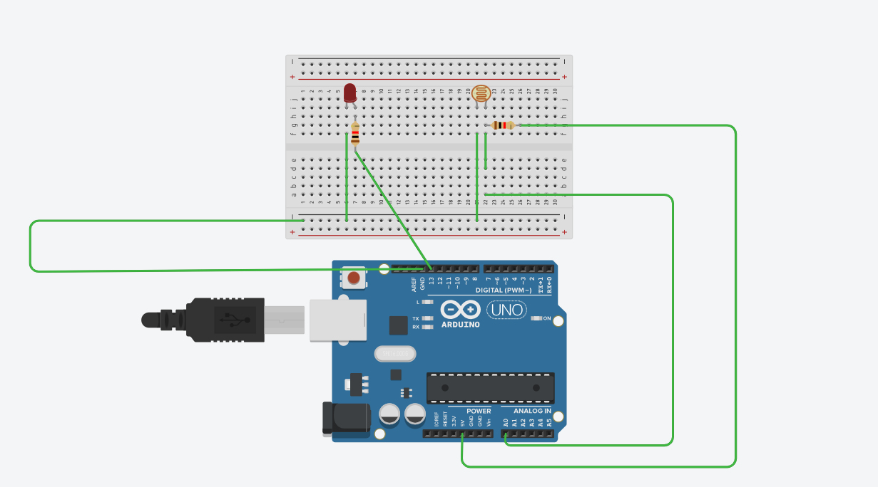

CODE:
const int ldrPin = A0;
const int ledPin = 13;
int threshold = 500;

void setup()
{
pinMode(ledPin, OUTPUT);
Serial.begin(9600);
}

void loop()
{
int val = analogRead(ldrPin);
Serial.println(val);
if (val > threshold) {
digitalWrite(ledPin, HIGH);
} else {
digitalWrite(ledPin, LOW);
}
delay(200);
}

